Hello Everyone!
In an attempt to increase professionalism in the club, there has been a template created for an email signature. The email signature will help indicate that you are a part of AMRA, your grade level, and contact information for anyone to be able to easily contact you. This is important when emailing people regarding AMRA activities, but it is also a way to demonstrate your involvement in the organization.
To create a signature in Outlook in the web browser, complete the following:
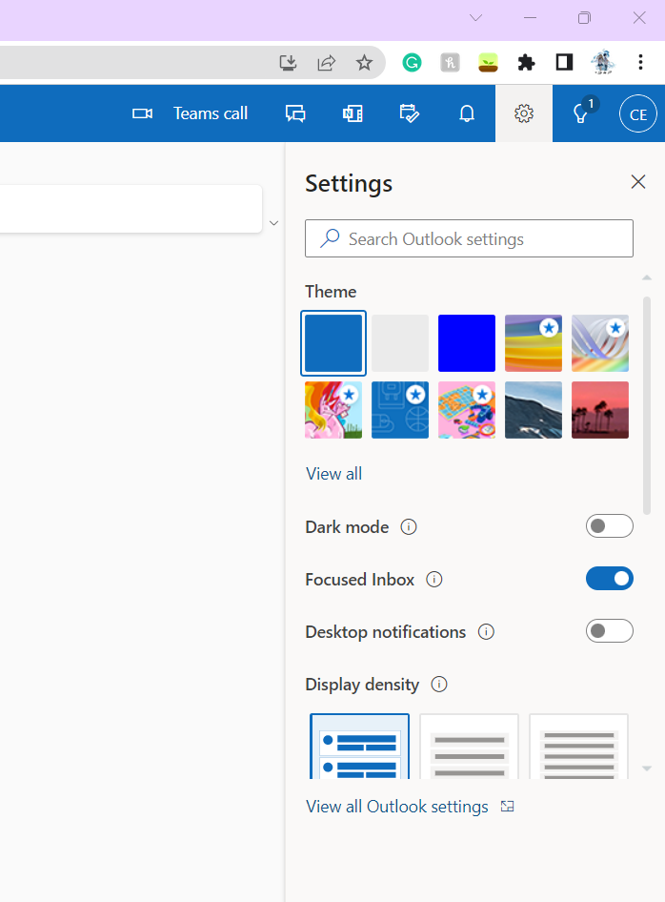
Click the settings tab, and the view all outlook settings. Once in the more signitures, search for signature in the search bar, and it should be the first option.
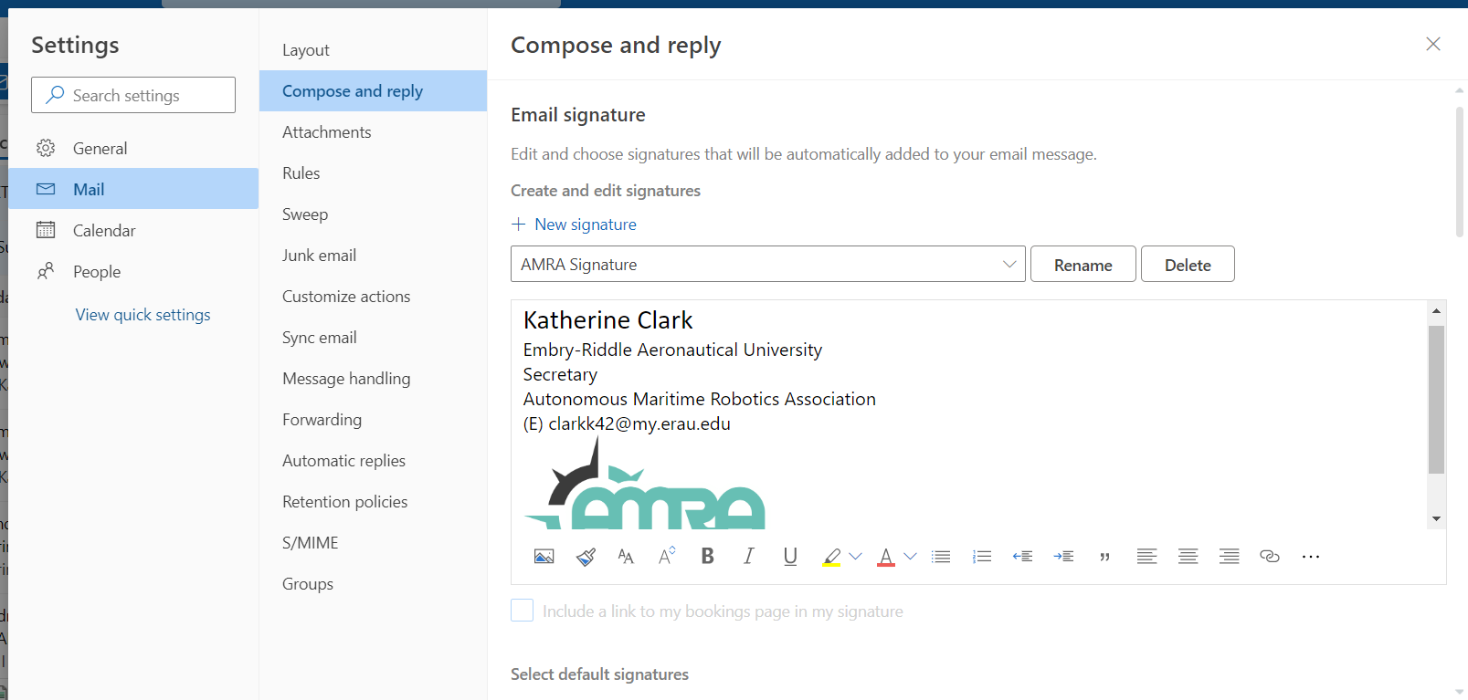
Once there, you click, New Signature, and add your information. The template is:
Your Name
Embry-Riddle Aeronautical University
Member
Autonomous Maritime Robotics Association
(E) YOUR EMAIL ADDRESS
(C) CELL PHONE Number (Optional)

Make sure to save it, and then scroll down to make sure the default settings are changed to include signature in the email.

If you have any questions, please reach out!

